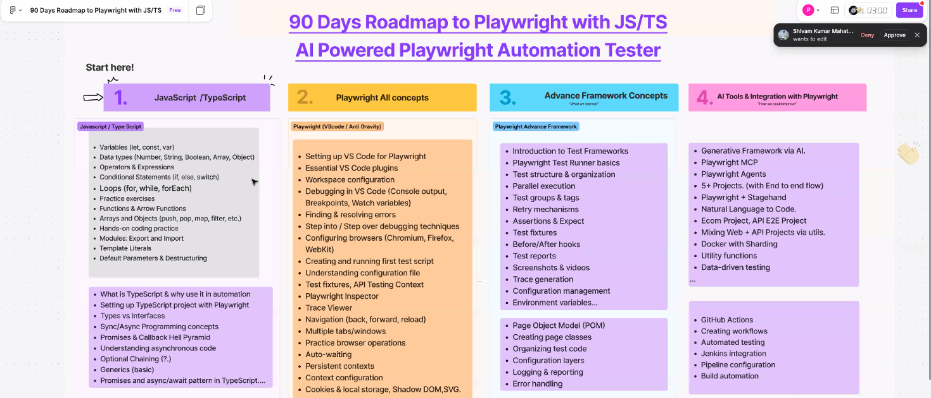
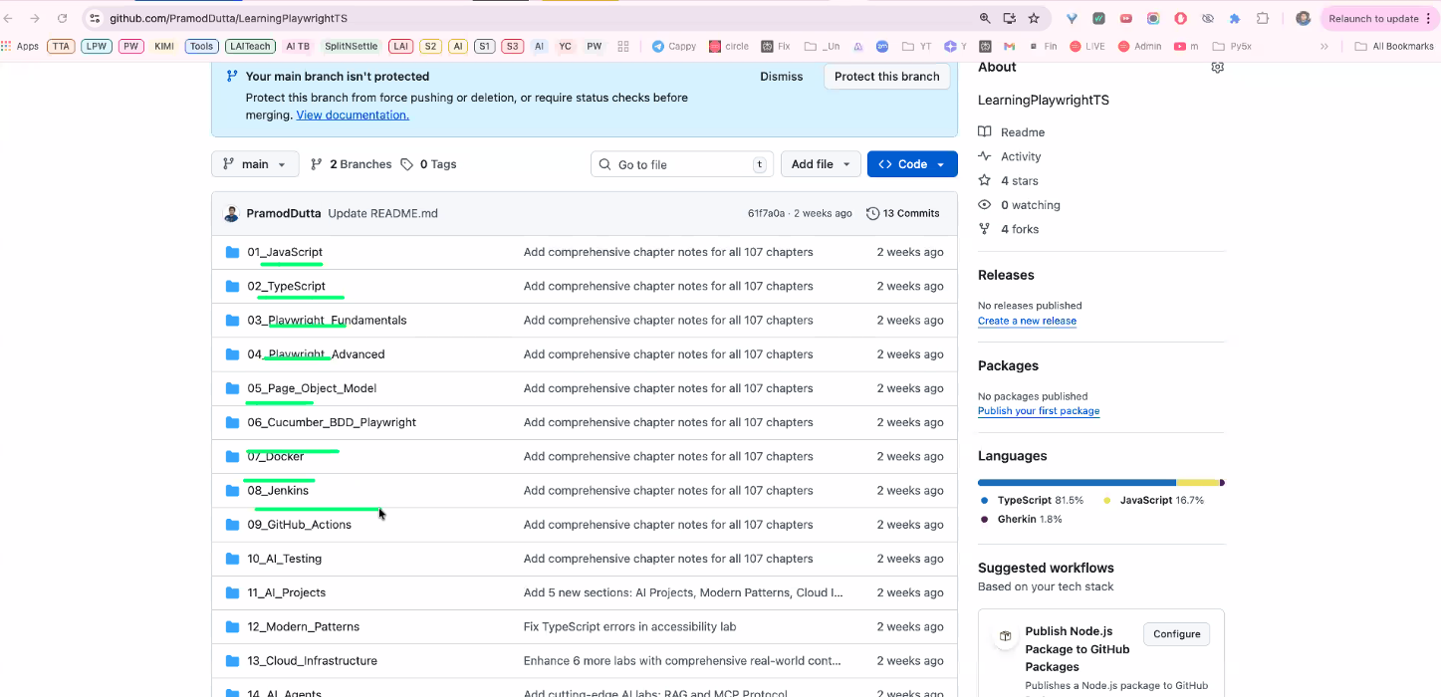
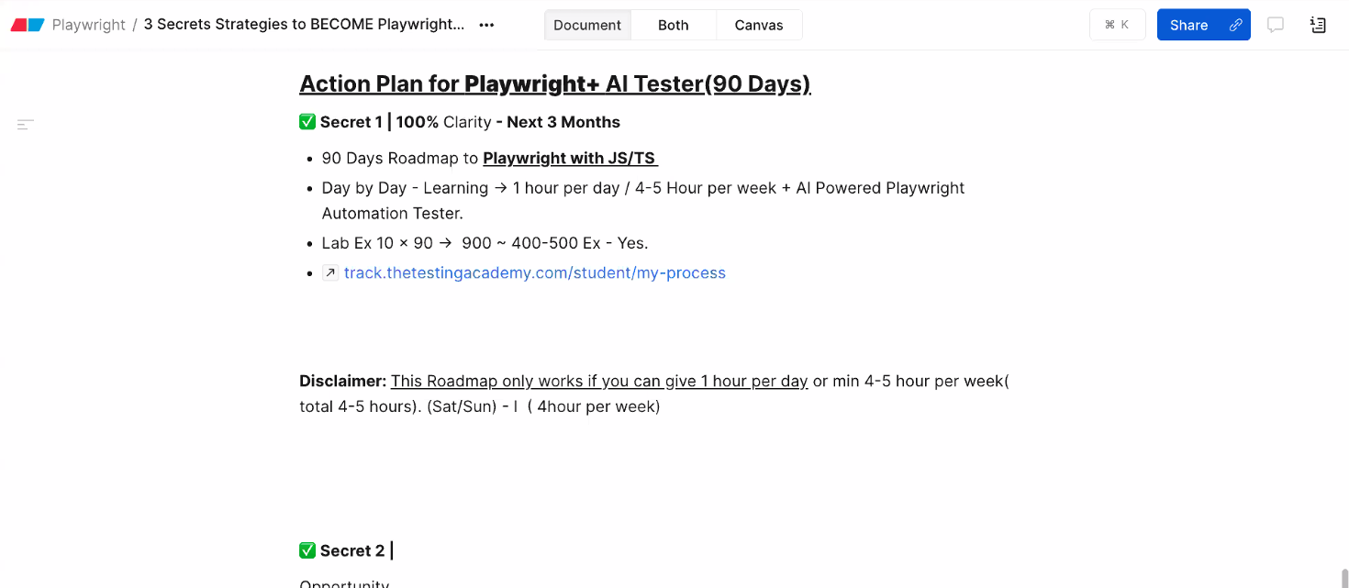
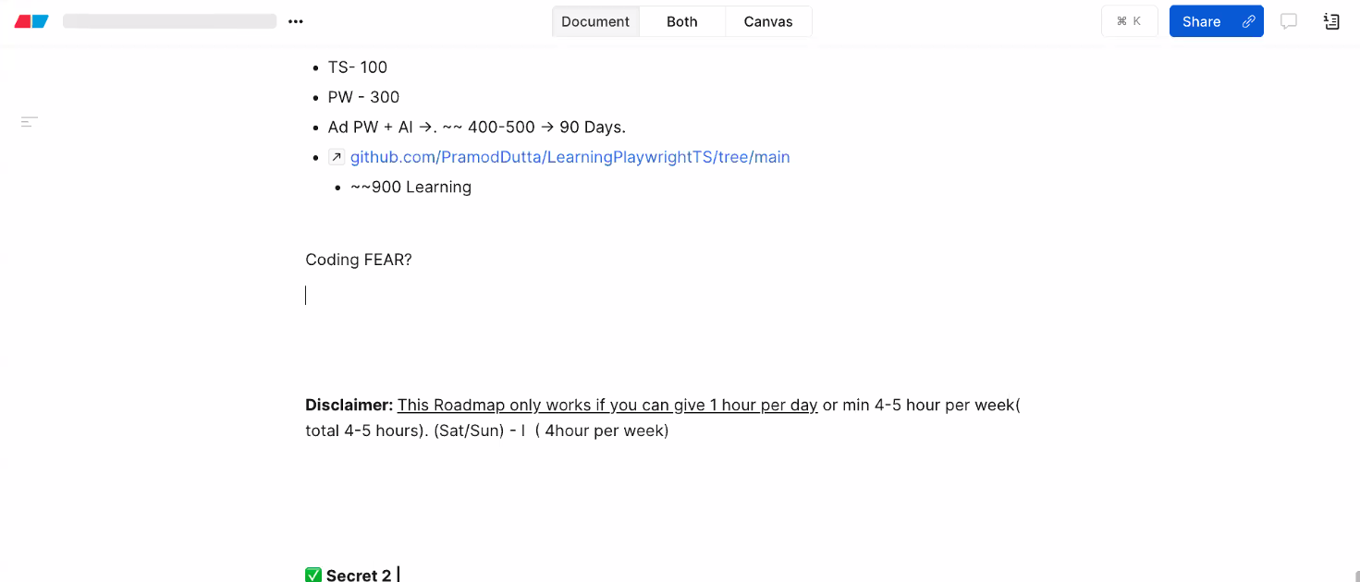
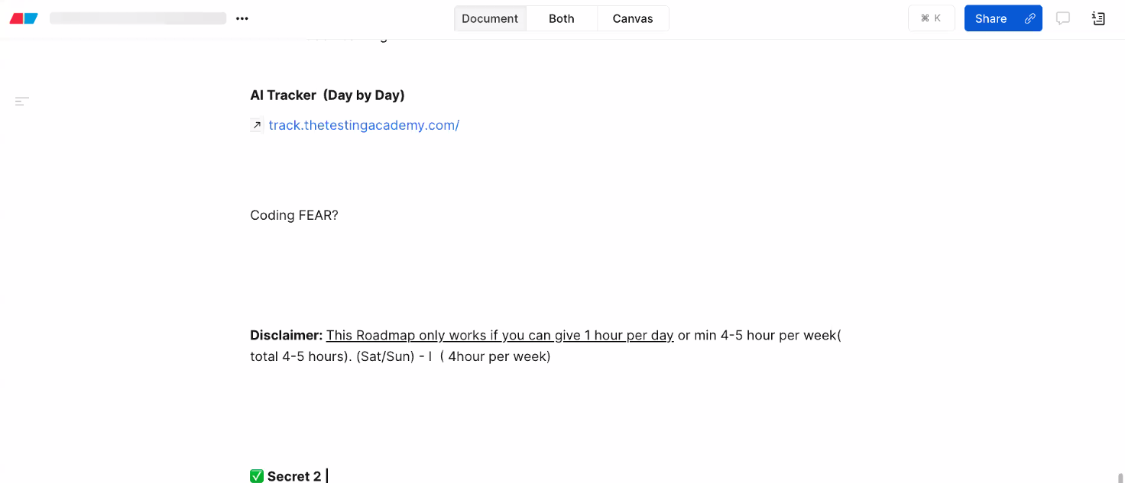
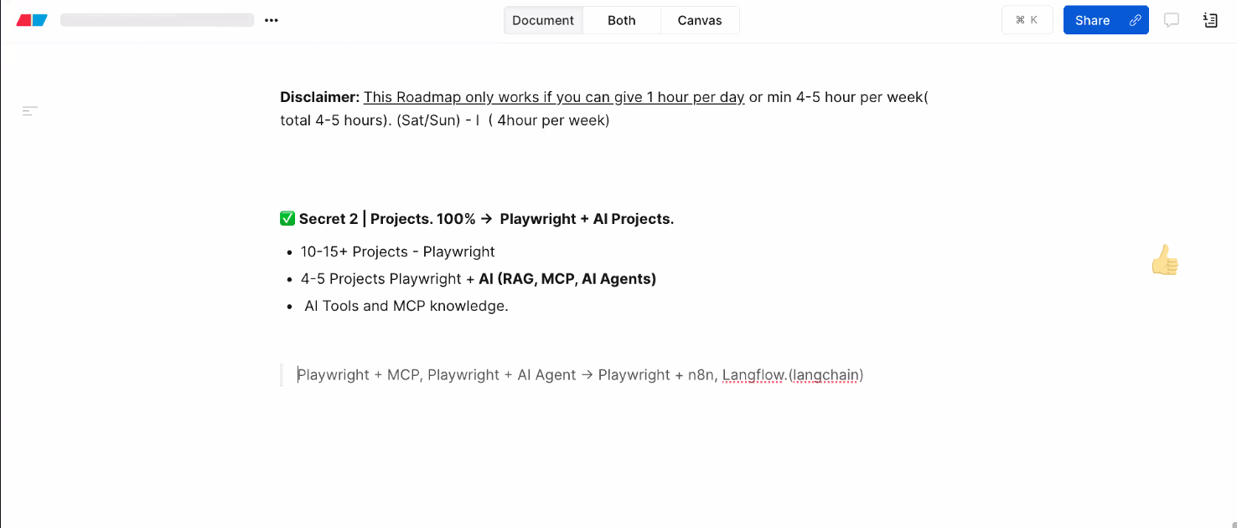
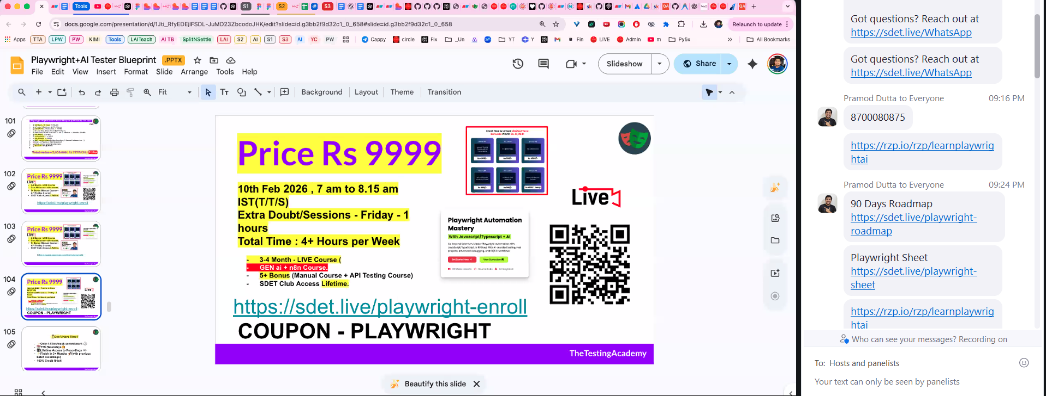
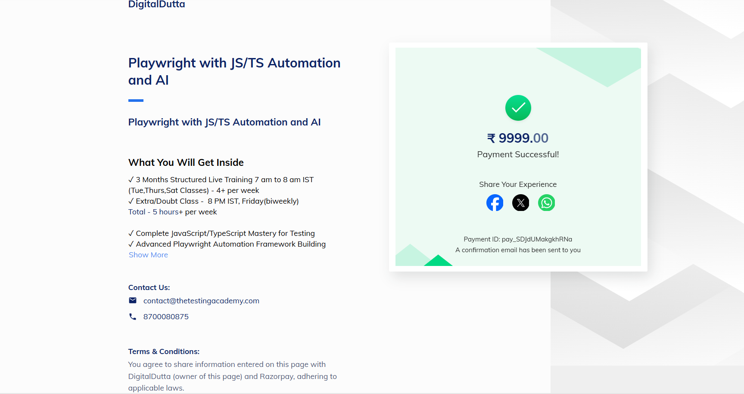
https://github.com/bhabanishankarpanda/Playwrite
Can you please create this project as Github project, add the .gitignore file and please try to push the code to this repo: https://github.com/bhabanishankarpanda/Playwrite.git
https://track.thetestingacademy.com/student/live-test
https://www.sdetclub.com/c/playwright-a791f6/
https://github.com/PramodDutta/LearningPlaywrightBatch
https://docs.google.com/document/d/1yz5Z-TfyZkzJ2g9xgZx29Y3ii8xaSGbg/edit#heading=h.muytthg9lxb6
https://app.eraser.io/workspace/Tz63v1Pz52oXHd70LdyM
https://www.figma.com/board/pkItIomNHwPzSdYrsWp1BT/90-Days-Roadmap-to-Playwright-with-JS-TS?node-id=1-13
https://docs.google.com/spreadsheets/d/1nuC9T39cfWPRk4aRO-uMeIS3hcnaCDV48tp6jRuH8SY/edit?gid=2043370034#gid=2043370034
https://git-scm.com/install/windows
https://code.visualstudio.com/docs/?dv=win64user
https://courses.thetestingacademy.com/courses/playwright-automation-mastery/contents/6993fe7200d92
https://docs.google.com/document/d/1w84B5NUwbhFte6Of3zv3X6fMGz7ZbiUFKR7cy4Pj95I/edit?tab=t.0
GitHub
Google Antigravity Download

